Paint the Emoji Project Code

The JavaScript code used to program the emoji template and animation (picture shown below) follows on the next page. Note that the animation cannot be seen until the emoji is painted over.

**Final result:**

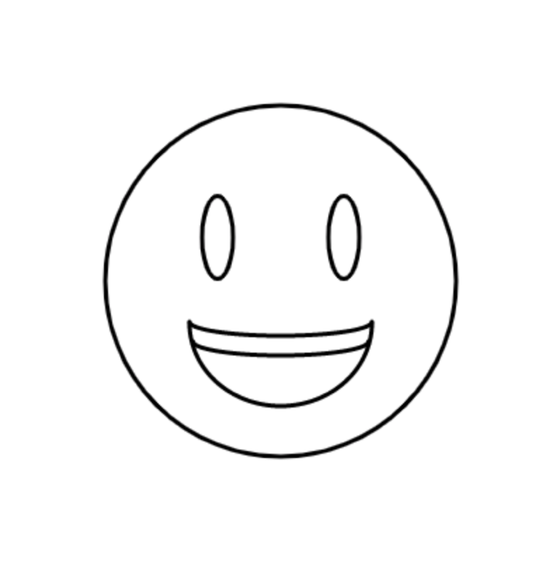

### 

### Code starts after this line.

var paintS = 10;

draw = function() {

/**EMOJI FACE**/

//General Styles

noFill();

strokeWeight(3);

//Face Shape

ellipse(200, 200, 250, 250);

//Eyes

ellipse(155, 169, 22, 59); //left eye

ellipse(245, 169, 22, 59); //right eye

//Mouth

//Top lip

arc(200, 229, 130, 20, 0, 180);

//Mouth

arc(200, 230, 130, 118, 0, 180);

//Teeth

arc(200, 243, 125, 20, 0, 180);

/**PAINT**/

fill(0, 0, 0);

noStroke();

if(mouseIsPressed){

ellipse(mouseX, mouseY, paintS, paintS);

}

};

### End of code.