“Turkey Dinner” Code

The full JavaScript code used to program the Thanksgiving turkey dinner (picture shown below) follows on the next page. The color-coded areas are the modifications made to the base program.

**Final result:**

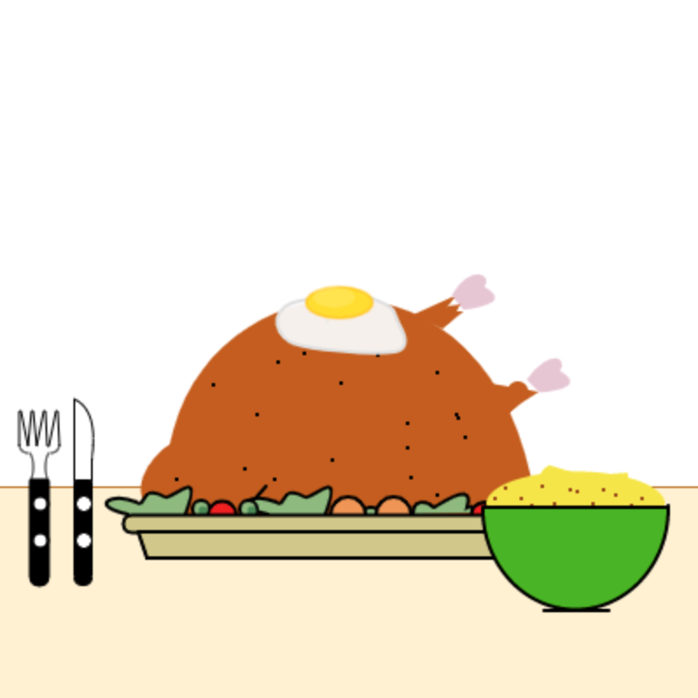

### 

### Code starts after this line.

/**Based on original code from 𝖅𝕰𝕲𝕺𝕽𝕬 **/

/**BACKGROUND**/

background(255, 255, 255);

strokeWeight(2);

stroke(186, 118, 41);

line(0, 280, 400, 280);

noStroke();

fill(255, 241, 209);

rect(0, 280, 400, 400);

/**TURKEY**/

noStroke();

//Turkey Legs

//Bones

fill(230, 198, 212);

//Back bone

beginShape();

vertex(302-43,233-63);

bezierVertex(313-43,214-63,326-43,221-63,321-43,228-63);

bezierVertex(339-43,238-63,310-43,241-63,309-43,240-62);

endShape();

//Front bone

beginShape();

vertex(302,233-15);

bezierVertex(316,214-15,326,221-15,321,228-15);

bezierVertex(339,238-15,310,241-15,309,240-15);

endShape();

//Leg meat

fill(194, 93, 25);

//part 1

beginShape();

vertex(254,189);

vertex(266,179);

vertex(262,179);

vertex(264,175);

vertex(257,176);

vertex(261,171);

vertex(259,171);

vertex(237,181);

endShape();

//part 2

beginShape();

vertex(269,233-15);

bezierVertex(186,226-15,192,316-15,263,284-15);

bezierVertex(287,265-15,281,256-15,309,240-15);

endShape();

//little point on front leg

noFill();

strokeWeight(12);

stroke(194,93, 25);

point(297,225);

//further elaboration

strokeWeight(2);

noStroke();

bezier(269,233-15,278,235-15,292,238-15,302,233-15);

beginShape();

vertex(302,233-15);

vertex(303,234-15);

vertex(299,237-15);

vertex(305,237-15);

vertex(303,240-15);

vertex(309,240-15);

endShape();

//Turkey Body

//General styles

fill(194, 93, 25);

//Main body

beginShape();

vertex(98,256);

bezierVertex(117,149,284,128,307,288);

bezierVertex(325,305,237,312,90,294);

bezierVertex(72,284,86,262,98,255);

endShape();

//Turkey Wing (hidden)

beginShape();

vertex(167,268);

bezierVertex(213,250,198,235,151,256);

bezierVertex(130,265,154,279,162,284);

endShape();

beginShape();

vertex(173,266);

bezierVertex(192,275,181,285,174,297);

endShape();

//Decorations on the Body

stroke(0);

line(153,279,147,286);

point(251,214);

point(196,220);

point(188,185);

point(102,275);

randomSeed(19);

for(var i = 0; i < 15; i++){

strokeWeight(2);

point(random(123,277),random(200,300));

}

/**VEGETABLES**/

//Vegetables

//General style

fill(144, 186, 123);

//Salads

beginShape();

vertex(74,295);

bezierVertex(51,290,65,282,79,288);

bezierVertex(85,292,81,277,95,285);

bezierVertex(99,288,118,265,107,295);

endShape();

beginShape();

vertex(74+80,295);

bezierVertex(51+80,290,65+80,282,79+80,288);

bezierVertex(85+80,292,81+80,277,95+80,285);

bezierVertex(99+80,288,118+80,265,107+80,295);

endShape();

beginShape();

vertex(237,295);

bezierVertex(237,286,245,287,249,291);

bezierVertex(250,291,273,274,268,291);

bezierVertex(272,289,273,294,272,294);

endShape();

beginShape();

vertex(237+36,295);

bezierVertex(237+36,286,245+36,287,249+36,291);

bezierVertex(250+36,291,273+36,274,268+36,291);

bezierVertex(272+36,289,273+36,294,272+36,294);

endShape();

//Other vegetables

//peas

ellipse(116,292,10,10);

ellipse(143,292,10,10);

ellipse(213,295,9,8);

//carrots

fill(237, 149, 81);

ellipse(200,295,20,20);

ellipse(226,295,20,20);

ellipse(289,295,10,10);

//tomatoes

fill(237, 33, 33);

ellipse(128,295,16,15);

ellipse(277,295,13,13);

//shadow on peas

fill(78, 138, 82);

noStroke();

ellipse(117,293,5,5);

ellipse(145,293,5,5);

/**PLATE**/

//Plate

//General plate styles

stroke(0);

fill(209, 199, 134);

//Plate

rect(71,295,238,10,9);

beginShape();

vertex(80,305);

vertex(85,320);

vertex(296,320);

vertex(301,305);

vertex(80,305);

endShape();

/**CUTLERY**/

//General Style

stroke(0, 0, 0);

//Fork

fill(0, 0, 0);

rect(28-10,275,10,60,1,1,40,40);

fill(255, 255, 255);

ellipse(34-10,289,9,9);

ellipse(34-10,310,9,9);

noFill();

strokeWeight(1);

arc(17,268,6,17,285,429);

arc(30,268,6,17,127,257);

arc(30,255,10,10,1,90);

arc(17,255,10,10,90,180);

beginShape();

vertex(12,256);

vertex(12,236);

vertex(13,236);

vertex(17,256);

vertex(19,236);

vertex(20,236);

vertex(22,256);

vertex(26,236);

vertex(27,236);

vertex(28,256);

vertex(29,256);

vertex(33,236);

vertex(34,236);

vertex(35,256);

endShape();

//Knife

bezier(43,229,59,236,53,260,54,264);

fill(0, 0, 0);

rect(43,275,10,60,1,1,40,40);

fill(255, 255, 255);

ellipse(49,289,9,9);

ellipse(49,310,9,9);

line(43,275,43,229);

line(53,275,53,263);

/**SIDES**/

//Egg

stroke(224, 224, 224);

fill(250, 250, 250, 240);

beginShape();

curveVertex(326, 183); //1

curveVertex(179, 172); //2

curveVertex(166, 196); //3

curveVertex(227, 202); //4

curveVertex(228, 184); //5

curveVertex(212, 171); //6

curveVertex(126, 147); //7

endShape();

stroke(255, 179, 0,100);

fill(255, 221, 0);

ellipse(195, 174, 38, 18);

noStroke();

fill(255, 236, 158, 100);

ellipse(192, 171, 24, 12);

//Mashed Potatoes

//Potatoes

fill(245, 229, 52);

ellipse(330, 290, 102, 20);

arc(330, 289, 102, 37, 180, 360);

noStroke();

arc(335, 273, 50, 20, -9, 217);

for(var i = 0; i < 88; i+=7){

stroke(153, 78, 20);

point(random(282, 286)+i, random(278, 292));

}

//Bowl

strokeWeight(2);

stroke(0, 0, 0);

fill(78, 181, 0);

arc(330, 292, 106, 115, -1, 181);

stroke(0, 0, 0);

line(312, 350, 348, 350);

line(278, 291, 382, 291);

draw = function() {

/**ANIMATION**/

mouseClicked = function(){

//ANIMATION

noStroke();

fill(255, 255, 255);

ellipse(mouseX, mouseY, 70, 70);

};

};

### End of code.