Simple Rocket Project Code

The JavaScript code used to program the simple rocket animation (picture shown below) follows on the next page.

**Final result:**

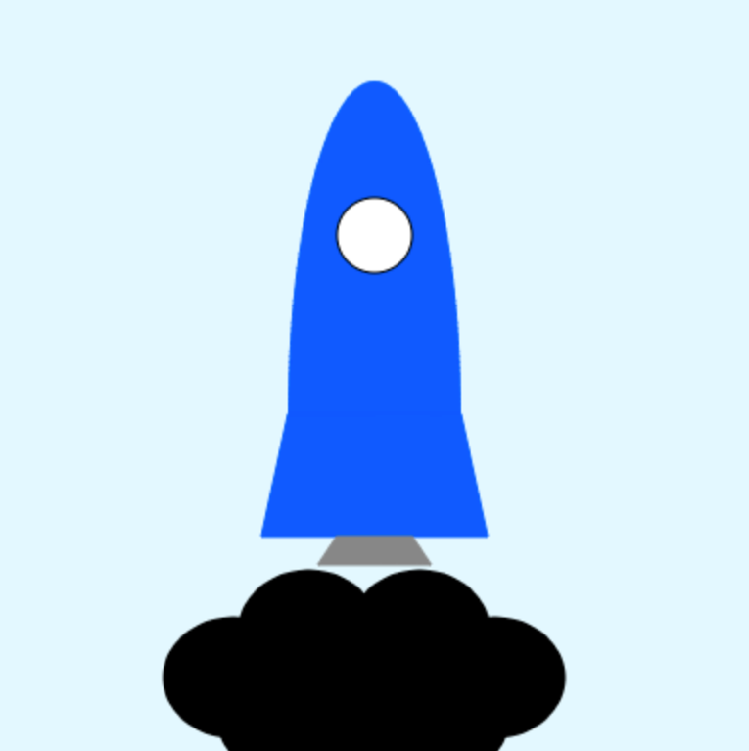

### Code starts after this line.

/**VARIABLES**/

var rocket = {

x: 200,

y: 220

};

var drawCloud = function(xPos, yPos){

noStroke();

ellipse(xPos, yPos, 75, 65);

ellipse(xPos + 40, yPos, 75, 65);

ellipse(xPos + 40, yPos - 25, 75, 65);

ellipse(xPos + 80, yPos, 75, 65);

};

var gasCloud = {

op: 0

};

/**DRAWING**/

draw = function() {

/**SETTING**/

background(227, 248, 255);

/**ROCKET**/

//General Rocket Styles

stroke(0, 89, 255);

fill(0, 89, 255);

//Rocket Body

arc(rocket.x, rocket.y, 91, 353, 180, 360);

quad(rocket.x - 60, rocket.y + 65, rocket.x - 46, rocket.y, rocket.x + 46, rocket.y, rocket.x + 60, rocket.y + 65);

//Capsule Window

fill(255, 255, 255);

stroke(0, 0, 0);

strokeWeight(1);

ellipse(rocket.x, rocket.y - 95, 40, 40);

//Exhaust Thruster

stroke(135, 135, 135);

fill(135, 135, 135);

quad(rocket.x - 30, rocket.y + 80, rocket.x - 20, rocket.y + 65, rocket.x + 20, rocket.y + 65, rocket.x + 30, rocket.y + 80);

//Animating the Rocket

rocket.y -= 0.5;

/**GAS CLOUDS**/

//Gas Clouds

fill(0, 0, 0, gasCloud.op);

drawCloud(125, 360);

drawCloud(184, 360);

drawCloud(154, 382);

//Animating the Gas Cloud

gasCloud.op += 3;

if(rocket.y < 50){

gasCloud.op += -12;

}

};

### End of code.