Rosie the Block Full Project Code
The JavaScript code used to program “Rosie the Block” (picture shown below) follows on the next page.

Final result:

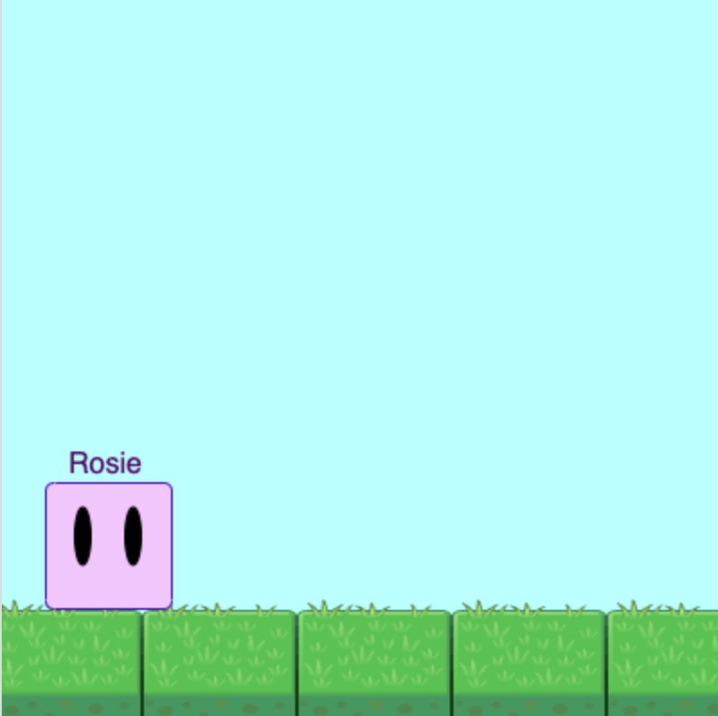

Code starts after this line.

/**CHARACTER FUNCTION AND VARIABLES**/

//Drawing Rosie the Block
var character = function(X, Y){
//Body
stroke(62, 18, 184);
fill(241, 199, 255);
rect(X, Y, 70, 70, 5);
//Eyes
stroke(0, 0, 0);
fill(0, 0, 0);
ellipse(X + 21, Y + 30, 9, 32);
ellipse(X + 49, Y + 30, 9, 32);
//Name
fill(83, 8, 102);
textSize(16);
text("Rosie", X + 13, Y - 5);
};

//Initial Variable Settings for Rosie
var cStart = {
x: 18,
y: 270
};

/**PROGRAM**/
draw = function() {

/**SETTING**/
//Sky
background(189, 255, 255);

//Ground (Grass)
for(var i = 0; i < 400; i += 86){
image(getImage("cute/GrassBlock"), -8 + i, 310, 86, 100);
}

//Drawing Rosie
character(cStart.x, cStart.y);

/**ANIMATION**/
//Moving Right
if(keyIsPressed && keyCode === RIGHT){
cStart.x += 2;
}
if(cStart.x > 330){
cStart.x -= 2;
}

//Moving Left
if(keyIsPressed && keyCode === LEFT){
cStart.x -= 2;
}
if(cStart.x < 0){
cStart.x += 2;
}

//Jumping
if(keyIsPressed && keyCode === UP){
cStart.y -= 2;
textSize(40);
text("Wee!", 160, 200);
}
else if(cStart.y !== 270){
cStart.y += 2;
}
if(cStart.y === 270){
cStart.y -= 2;
}
if(cStart.y < 30){
cStart.y += 2;
}
};

End of code.

