



Problem 1
Simplify completely: 7x – 2x² – x
- 6x² – 2x
- 4x
- 6x – 2x²
- 2x² + 6x
- 8x – 2x²

Your answer:

Your solution process (optional):

Problem 2
Durga is on a hot air balloon secured to a rope staked to the ground. The rope is taut, and the balloon is hovering directly over Mairéad. If Mairéad is 40 m from the place where the rope is staked down, and the balloon is 45 m in the air, how long is the rope?
- 20 m
- 40 m
- 5√(145) m
- 59 m

Your answer:

Your solution process (optional):

Problem 3
The greatest common factor of 2²⁰⁰⁴ and 2²⁰⁰⁵ is
- 1
- 2
- 2²⁰⁰⁴
- 2²⁰⁰⁵
- 2²⁰⁰⁹

Your answer:

Your solution process (optional):

Problem 4
Multiply and simplify completely: (a – b)²
- a² + 2ab + b²
- a² + b²
- a² – b²
- a² – 2ab + b²
- a²b²

Your answer:

Your solution process (optional):

Problem 5
Simplify the fraction:
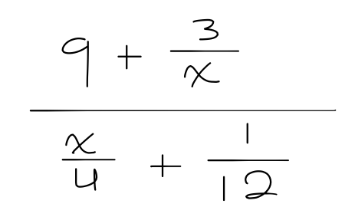
- 36
- 36/x
- x/36
- 1
- 3x/4

Your answer:

Your solution process (optional):

Problem 6
Perform the indicated operations:
[(8x⁸ + 8) – (12x⁷ + 7x²)] – [(4x⁸ – 7x⁴ + 7x) + (7x + 11)(7x – 1)]

- 4x⁸ + 12x⁷ – 7x⁴ – 56x² – 77x + 19
- 4x⁸ – 12x⁷ + 7x⁴ – 56x² – 77x + 19
- 4x⁸ – 12x⁷ + 7x⁴ + 56x² + 4x + 19
- -4x⁸ + 12x⁷ – 7x⁴ – 14x² – 4x + 19
- -4x⁸ + 12x⁷ + 7x⁴ – 56x² – 11x + 19

Your answer:

Your solution process (optional):

Problem 7
The sum of the lengths of the edges of a cube is L. Find the volume of this cube.
- L³/4096
- L³/1728
- L³/512
- L³/27
- L³/3

Your answer:

Your solution process (optional):

Problem 8
Find the slopes of the lines that are parallel and perpendicular to the line through the pair of points: (-3, 4) and (-2, -4)
- Parallel: -1/8; perpendicular: 8
- Parallel: 8; perpendicular: -1/8
- Parallel: 1/8; perpendicular: -1/8
- Parallel: -8; perpendicular: 1/8
- Parallel: -8; perpendicular: 8

Your answer:

Your solution process (optional):

Problem 9
Solve the system of equations.
6y + 2x + 2 = 0
2y + 6x = 10

- No solution
- Infinitely many solutions
- (-1, 2)
- (2, -1)

Your answer:

Your solution process (optional):



Problem 1
Find the measure of ∠6, ∠4, and ∠7.
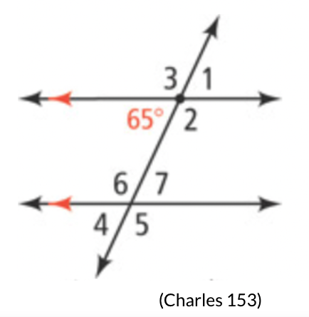

Your answer:

Your solution process (optional):

Problem 2
Find the measure of ∠2.
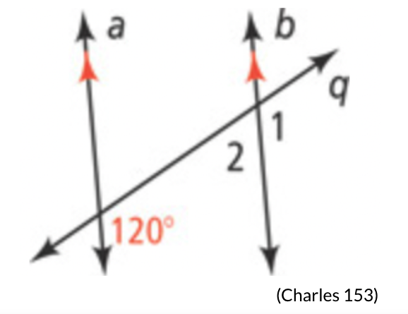

Your answer:

Your solution process (optional):

Problem 3
Find the measure of ∠1.
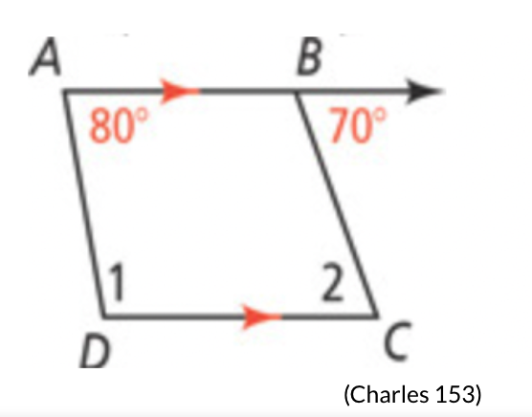

Your answer:

Your solution process (optional):

Problem 4
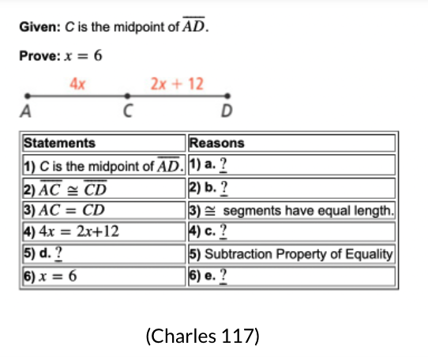

Your answer:

Your solution process (optional):

Problem 5
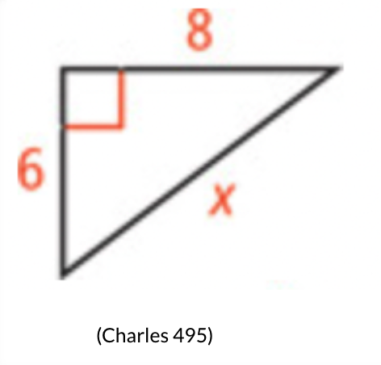

Your answer:

Your solution process (optional):

Problem 6
Is this set of numbers a Pythagorean triple?
4, 5, 6

Your answer:

Your solution process (optional):

Problem 7
Find the sine, cosine, and tangent of ∠A.
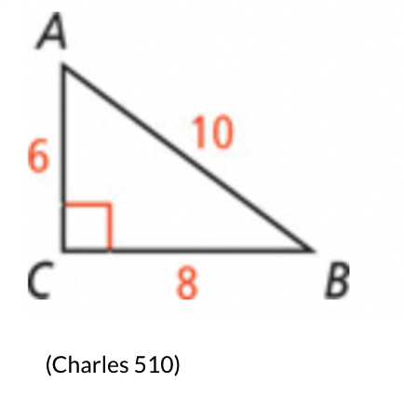

Your answer:

Your solution process (optional):

Problem 8
Solve for x.
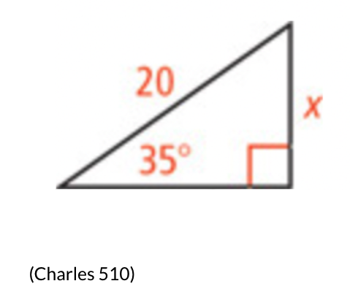

Your answer:

Your solution process (optional):



Problem 1
Fill in the blanks. Choices: = , <, or >
- 5 + 2x __ 4 if x = ½
- 18x² – 30 __ 42 if x = 2
- 999,999,999x – 1,000,000x __ 1 if x = 0

Your answer:

Your solution process (optional):

Problem 2
Aynsley is doing some math problems from her Algebra 2 textbook and wants to know when she’ll ever be done! She has a total of 70 questions to do, and she works at a rate of 3 questions per minute for the first ten minutes…but then she gets tired and her rate drops to only 2 questions per minute. Will 25 minutes be enough time for her to finish all her questions?

Your answer:

Your solution process (optional):

Problem 3
Solve the equation for the given variable:


Your answer:

Your solution process (optional):

Problem 4
What are the roots of the following equation?
f(x) = x² – 2x + 17

Your answer:

Your solution process (optional):

Problem 5
Math the image to its corresponding conic section—and for bonus points, give its general equation, too! (Assume the image’s center/vertex is the origin.)
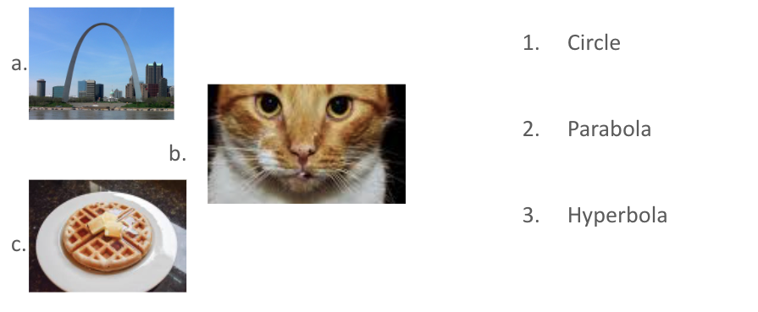

Your answer:

Your solution process (optional):

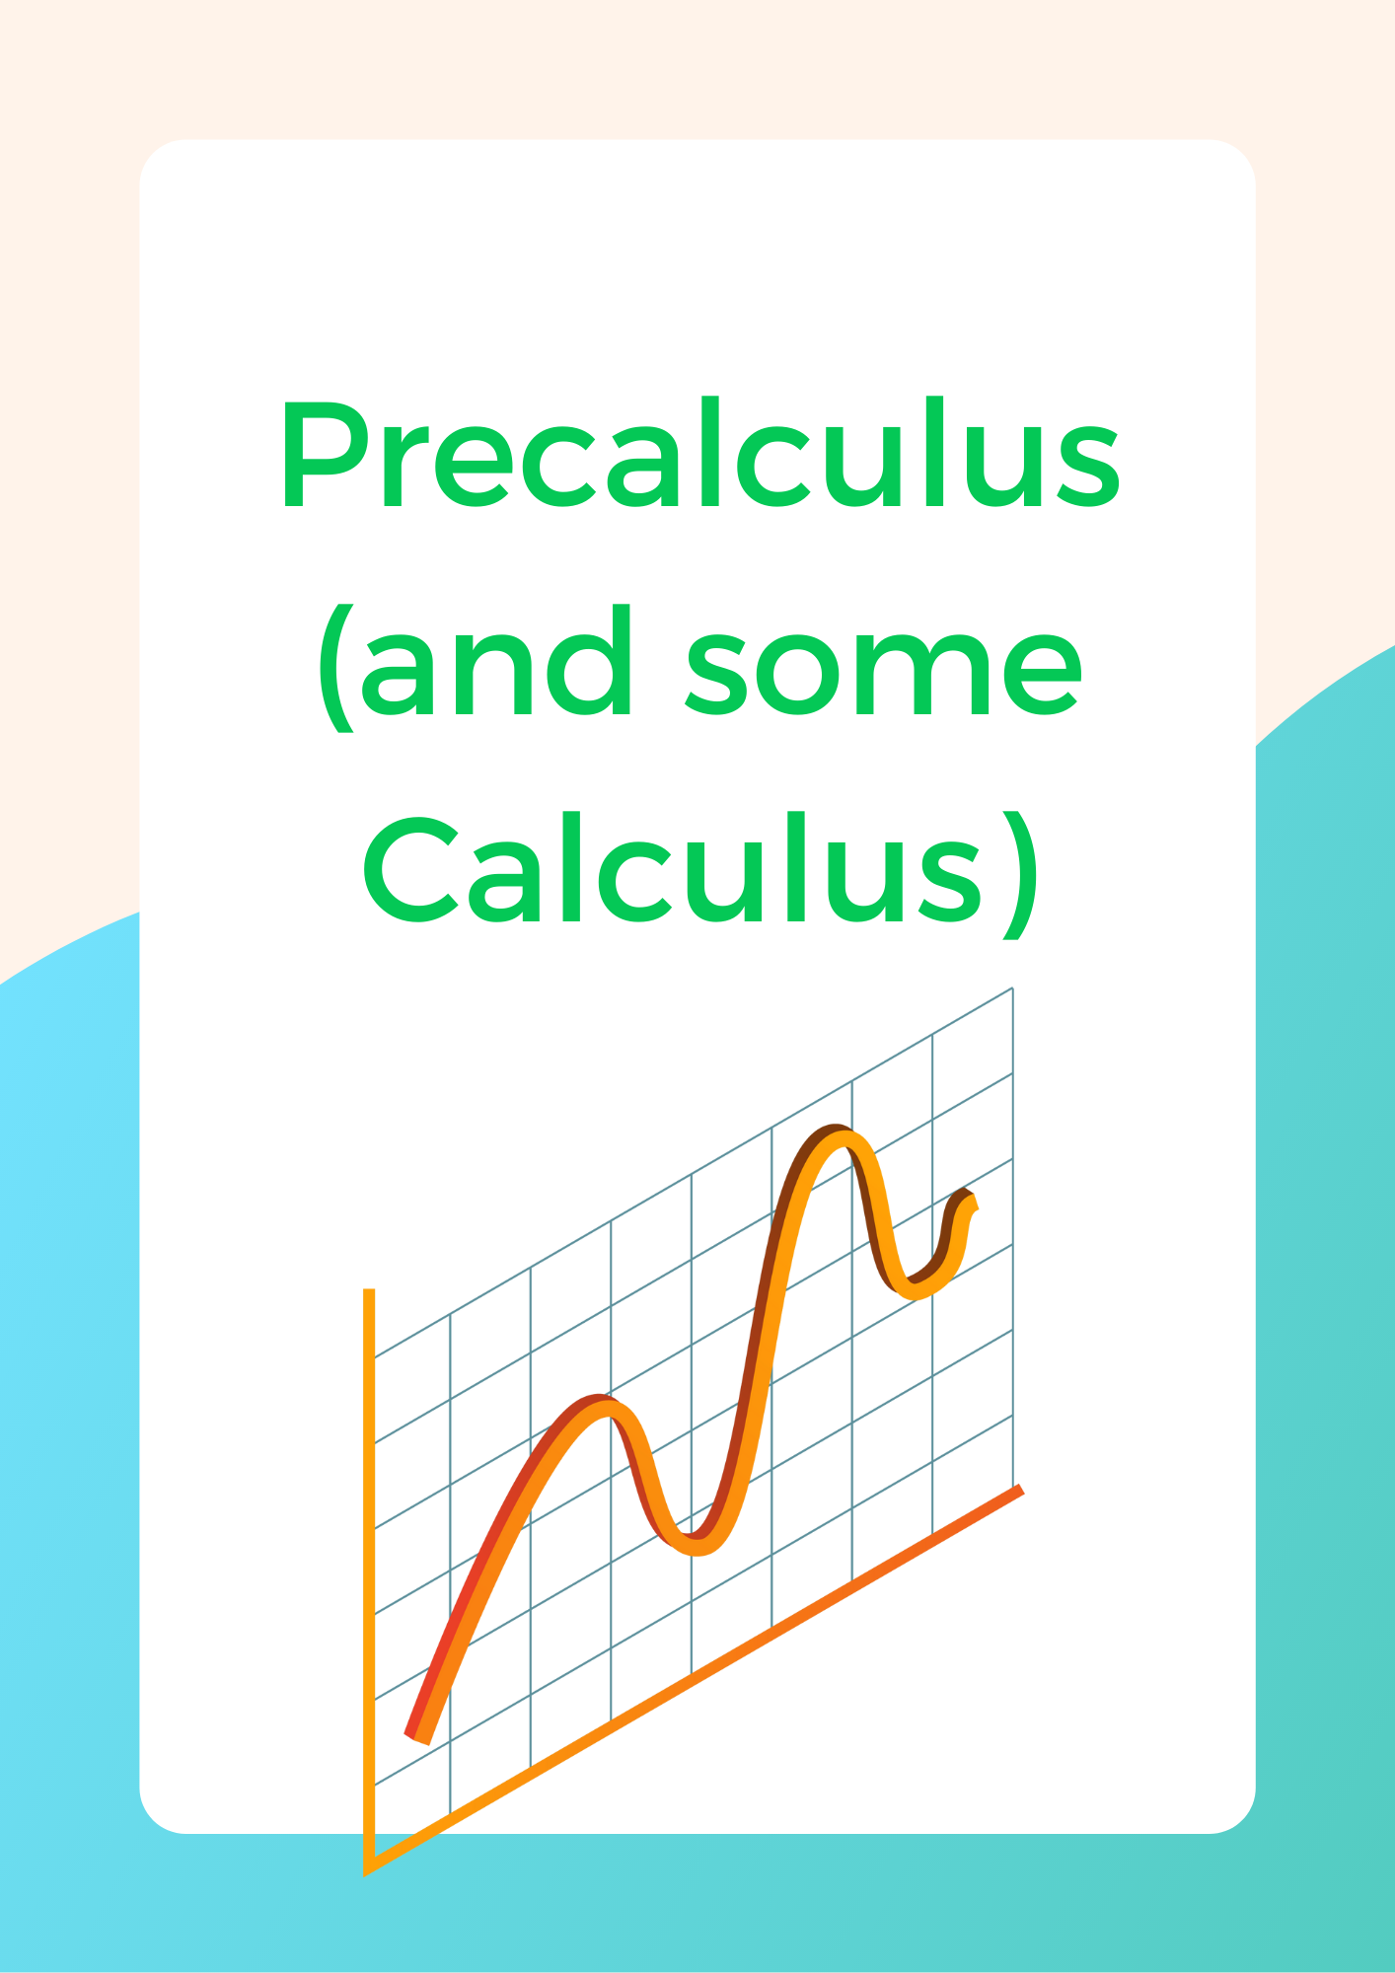

Problem 1
What is the x-value of 180 degrees on the unit circle?

Your answer: -1

Your solution process (optional):
cos(180˚) = cos(π) = -1

Problem 2
What are the solutions to x² + 6x + 9?

Your answer: x = -3

Your solution process (optional):
x² + 6x + 9 = (x + 3)²
x = -3

Problem 3
What is the 7th term in this sequence?
1, 3, 9, 27, …

Your answer: 729

Your solution process (optional):
27(3) = 81
81(3) = 243
243(3) = 729

Problem 4
What is the magnitude of the vector <3, 4>?

Your answer: 5

Your solution process (optional):
√(3² + 4²) = √(9 + 16) = √25 = 5

Problem 5
Write x(t) = t² and y(t) = -2t in the form y(x).

Your answer: y = -2√x

Your solution process (optional):
t = √x
y = -2(√x) = -2√x

Problem 6
Which is instant rate of change? Which is average rate of change?
- The speed of a car at 3 seconds is 60 miles per second.
- The average speed of a car over 5 seconds passed is 50 miles per second.
- The amount of water being dumped from a cup is 5 gallons per second at 6 seconds.

Your answer:

Your solution process (optional):



