



Problem 1
Solve for x:
8 – 5x = x + 15

Your answer:

Your solution process (optional):

Problem 2
Solve for x:
0.5(5 – 7x) = 8 – (4x + 6)

Your answer:

Your solution process (optional):

Problem 3
Solve for y:
py + 7 = 6y + q

Your answer:

Your solution process (optional):

Problem 4
Solve for x:
|2x - 1| = 5

Your answer:

Your solution process (optional):

Problem 5
Are the functions h(x) = 2x – 3 and g(x) = -3x + 7 parallel, perpendicular, or neither?

Your answer:

Your solution process (optional):

Problem 6
Solve for x:
|3x + 2| = |x – 1|

Your answer:

Your solution process (optional):

Problem 7
Solve for x:
a(5 – x) = bx – 8

Your answer:

Your solution process (optional):

Problem 8
Elle paints walls for a living. She paints at a constant speed, and then she takes a constant amount of time to clean up. The table compares the total area Elle paints (in square meters) and the time it takes Elle to finish painting and cleaning up (in hours).

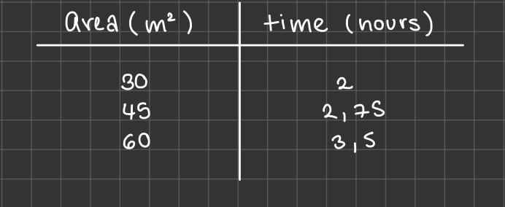

How long does it take Elle to paint 1 square meter?

Your answer:

Your solution process (optional):

Problem 9
How many solutions does the following equation have?
3z + 9 + 14z = 4z + 5
- no solutions
- exactly one solution
- infinitely many solutions

Your answer:

Your solution process (optional):

Problem 10
Simplify, assuming z is positive.
5√(14z²) • 4√(21z³)

Your answer:

Your solution process (optional):

Problem 11
In which step was a mistake made?

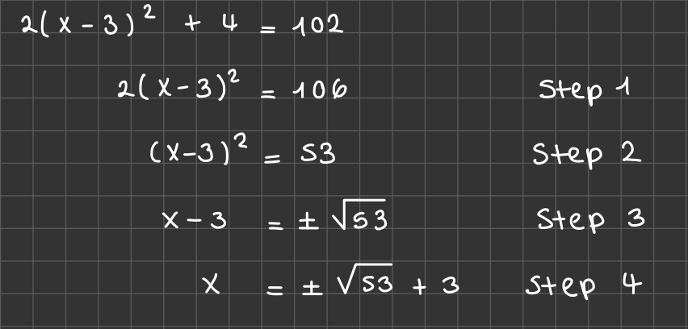

Your answer:

Your solution process (optional):

Problem 12
Solve the system of equations:
{2x + y = 8
{3x – 2y = 5

Your answer:

Your solution process (optional):

Problem 13
Solve for x:
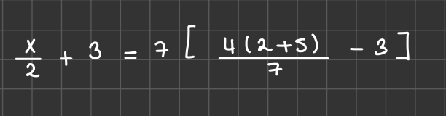

Your answer:

Your solution process (optional):

Problem 14
Solve using the quadratic formula:
3x² – 7x + 2 = 0

Your answer:

Your solution process (optional):

Problem 15
Factor x² – 5x + 6.

Your answer:

Your solution process (optional):

Problem 16
Solve the system of equations:
{x² + y = 10
{xy = 24

Your answer:

Your solution process (optional):

Problem 17
Solve the system of equations:
{2x² + y = 2
{y = 2x + 2

Your answer:

Your solution process (optional):

Problem 18
Simplify:
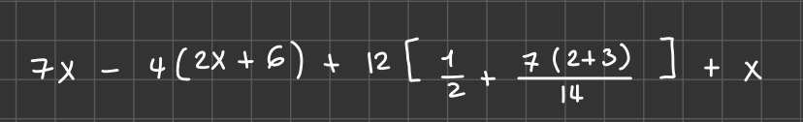

Your answer:

Your solution process (optional):

Problem 19
Solve for y:
32x + 5 > 6(4x + y) + 3

Your answer:

Your solution process (optional):

Problem 20
Solve the system of equations:
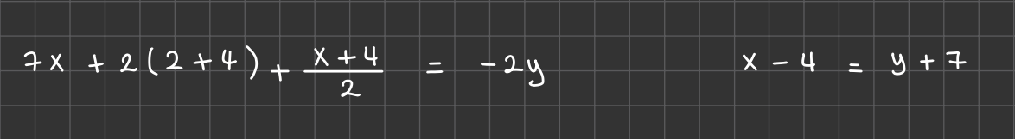

Your answer:

Your solution process (optional):



Problem 1
How far am I from ice cream? Let’s say I am at (3, 4) and. the ice cream is at (6, 12). Use the distance formula.

Your answer:

Your solution process (optional):

Problem 2
Evaluate tan(π/3).

Your answer:

Your solution process (optional):

Problem 3
Evaluate tan(390˚).

Your answer:

Your solution process (optional):



Problem 1
What is the degree of the following polynomial?
3x⁴ – 2x² + x – 2

Your answer:

Your solution process (optional):

Problem 2
Solve for x in the following equation.
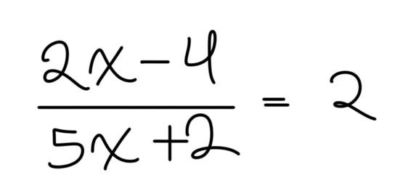

Your answer:

Your solution process (optional):

Problem 3
Rewrite 4³ = 64 in logarithmic form.

Your answer:

Your solution process (optional):

Problem 4
Convert 270˚ to radians.

Your answer:

Your solution process (optional):

Problem 5
Let f(x) = x^{x} + x. Find f(3).

Your answer:

Your solution process (optional):

Problem 6
Let f(x) = x^{x} + x. Find f(-2).

Your answer:

Your solution process (optional):

Problem 7
What does x equal in the following equation?
x = log₂(8)

Your answer:

Your solution process (optional):

Problem 8
Let f(x) = x³ – 2x. Let g(x) be f(x) translated 2 units up and 3 units right. Find g(x).

Your answer:

Your solution process (optional):

Problem 9
Find the solution(s) to the following system of equations.
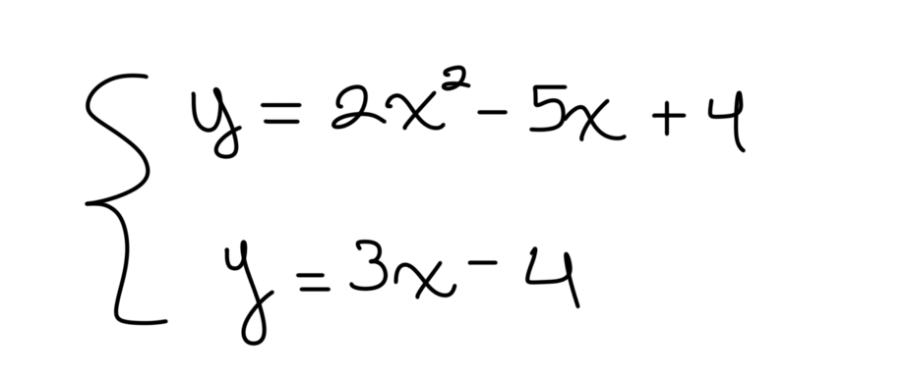

Your answer:

Your solution process (optional):

Problem 10
Let f(x) = 2x. What is the average value of the function on the interval [0, 5]?

Your answer:

Your solution process (optional):

Problem 11
Prove that sin²(𝜃) + cos²(𝜃) = 1.

Your answer:

Your solution process (optional):

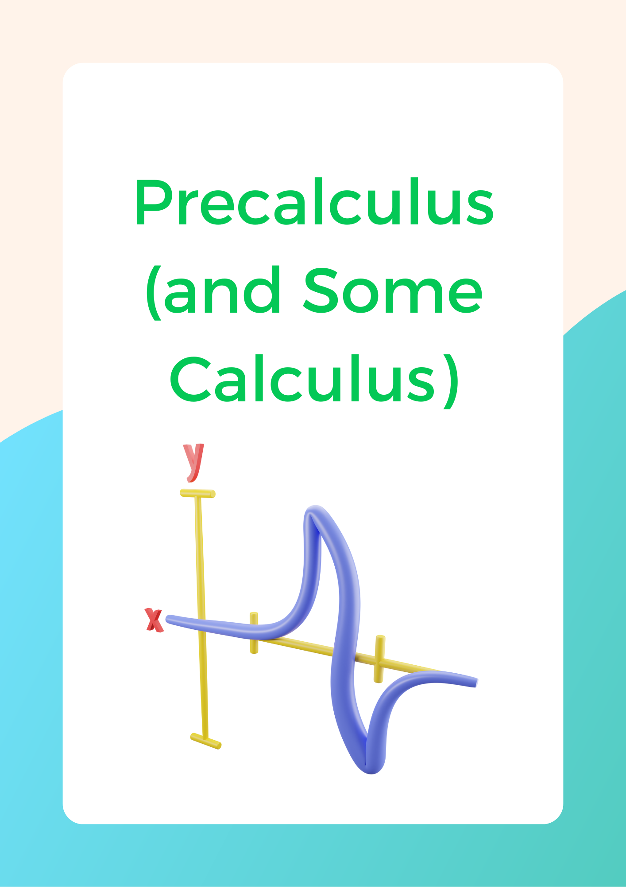

Problem 1
Convert the following coordinate pairs to polar form:
- (1, 2)
- (2, 4)
- (3, 6)

Your answer:

Your solution process (optional):

Problem 2
Convert the following coordinate pairs to rectangular form:
- (1, π/2)
- (8, 2π/3)
- (4, π)

Your answer:

Your solution process (optional):

Problem 3
Convert the following equations to polar form:
- 2x² + 2y² = 1
- y = √x

Your answer:

Your solution process (optional):

Problem 4
Convert the following equations to rectangular form:
- r = sin(2𝜃)
- r = 2 – 2sin(𝜃)

Your answer:

Your solution process (optional):

Problem 5
List the end behaviors as x ∞ for the functions a(x) through c(x).
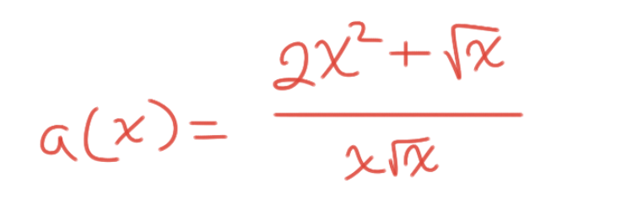
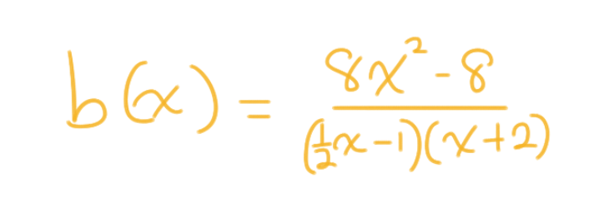
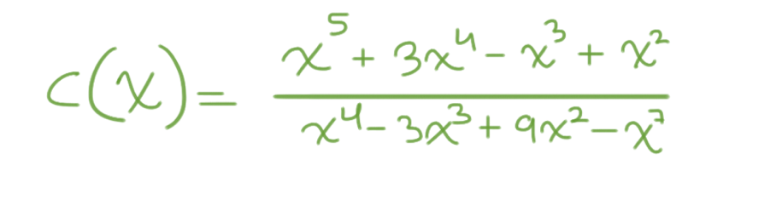

Your answer:

Your solution process (optional):

Problem 6
Which of the following statements is true about f(x)?
- It has no vertical asymptotes.
- It has no horizontal asymptotes.
- It has a removable discontinuity at x = -1.
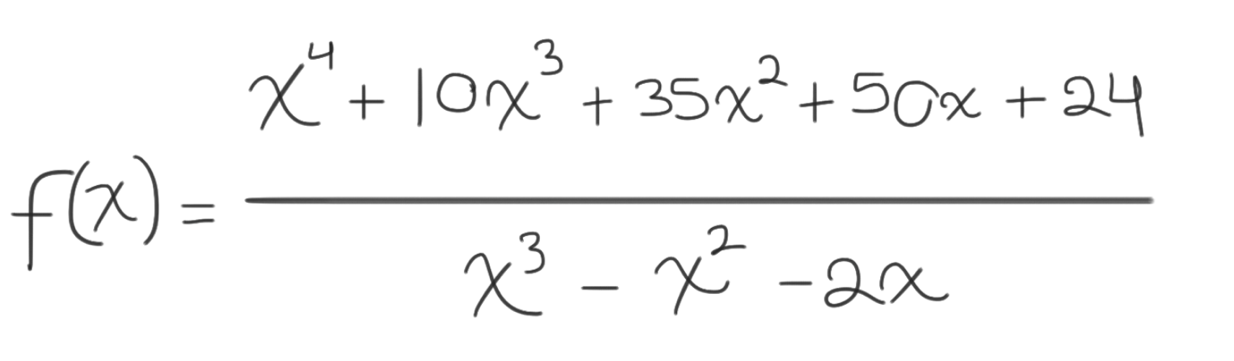

Your answer:

Your solution process (optional):

Problem 7
Find the equation of the tangent line at x = 6 for f(x) = x³.

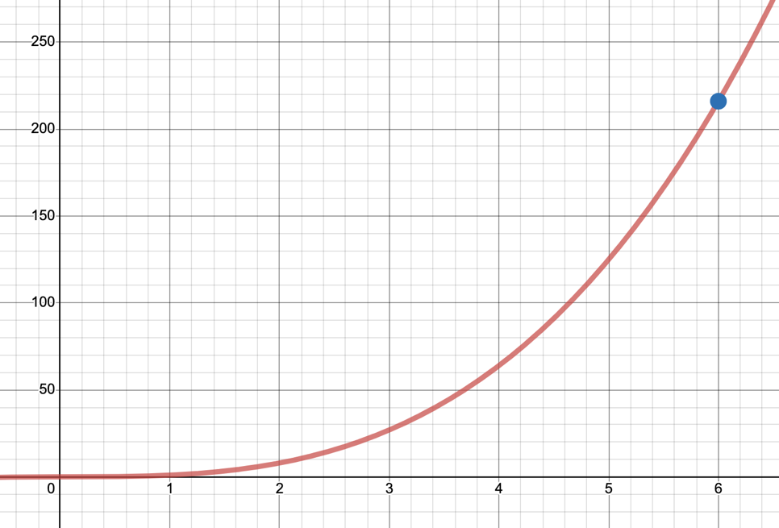

Your answer:

Your solution process (optional):

Problem 8
The equation of the tangent line to f(x) = √x at x = 4 is y = x/4 + 1. Identify f’(4) and then write the equation of the normal line to f(x) at x = 4.

Your answer:

Your solution process (optional):

Problem 9
Find the indefinite integral of the following functions:
- f(x) = 2x²
- g(x) = √x + 1/x²

Your answer:

Your solution process (optional):

Problem 10
Find the integral of the following functions on the given intervals:
- f(x) = 2x² on [-1, 1]
- g(x) = √x + 1/x² on [2, 3]

Your answer:

Your solution process (optional):



